Likelihood Methods in Ecology Syllabus
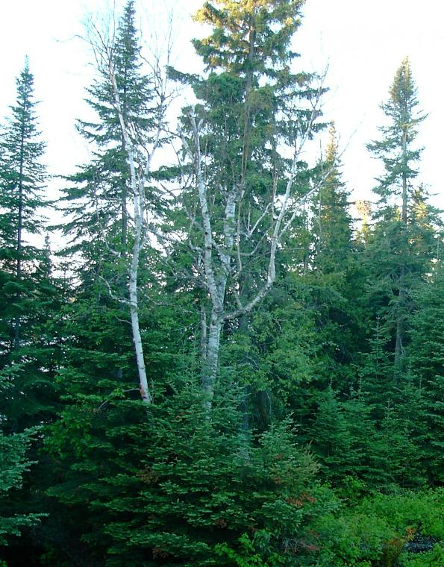
Dates : February 6, 7, 8.
Salles:
PK-M860 salle Q pour le 6 de 0830-Midi et 1330 - 1700
PK -S1590 salle L pour le 7 de 0830-Midi et 1330 - 1700
PK-S1525 salle J pour le 8 de 0830-Midi et 1330 - 1530

Language : Primarily English

For more information about the course contact:
Michael J. Papaik
centre d'étude de la forêt
dép. des sciences biologiques
UQAM, C.P. 8888, Succ. Centre-Ville
Montréal, QC H3C3P8
(514) 987-3000 x2357
Email Dr. Papaik

This is an ambitious syllabus and an ambitious short course. My main objective is to give you enough overview that you understand the outline of using Likelihood Theory and Information Theory for scientific inference, but with enough detail that you have some insight into actually doing an analysis using this approach. This course is too brief to be able to give you the hands on experience you need, but I hope it at least points you in the right direction to get started.
I hope all students read all 22 of the following papers and will be prepared at least with questions. This is a lot of material, but do not despair and do not get bogged down with the details. Some of these papers are very technical. Focus on the concepts. To help facilitate discussion I have assigned students to one of three groups. Please be prepared to lead discussions on each of the papers assigned to your group. I want to encourage all members of each group to be prepared to lead a detailed discussion of each paper assigned to your group, however, if you like, each group may divide up the papers among themselves (before February 6th) so that at least one member of each group will be prepared to give a one minute overview of the paper and facilitate the detailed discussion. As I said at the beginning of this paragraph, however, each student should read every paper at least well enough to come with questions, however basic they may be. This course will succeed only if we are able to generate a lot of discussion amongst ourselves. In other words, I will not lecture much.

Group 1 | Group 2 | Group 3
Guillaume Sainte-Marie | Juan Posada | Henrik Hartmann
Tim Work | Mathieu Bouchard | Tyler Rudolph
Dominic Cyr | Christiane de Albuquerque Martins | Josh Nowak
Bastien Fontaine | Marie-Lyne Arbor | Martin-Hughes St. Laurent
Josh Jacobs | Nicolas Bergeron | Xavier Morin
Alain Paquette |  | Fred Boivin
Robert Schneider (alt) | Dan Kneeshaw (alt)

All papers can be downloaded ftp from the CEF website at :
DAY 1: Wednesday, February 6th Topic : Likelihood Theory
Salle: PK-M860 salle Q
8:30 – 10:00 Lecture: Probability, Likelihood and Information
10:00 – 10:30 Break:
10:30 – Noon Discussion – Topics in Likelihood Theory
Papers for group discussion (90 minutes per group) –
Group 1 (4 papers) – Probability Theory
Hilborn and Mangel 1997 Chapters 1, 2 and 3 Probability and probability models: know your data. in The Ecological Detective: Confronting Models with Data. Princeton University Press. Princeton, NJ.
Limpert, E., W. A. Staehl. 2001. Log-normal distributions across the sciences: keys and clues. Bioscience 51: 341-352.

12:00 – 1:00 Lunch
1:30 – 5:00 Discussion Groups Continued:
Group 2 (3 papers) – Likelihood Theory
Edwards, E. W. 1992. The framework of inference. Chapter 1 (Pages 1-7) in Likelihood. Johns Hopkins University Press. Baltimore, MD.

Edwards, E. W. 1992. The concept of likelihood. Chapter 2 (Pages 8-24) in Likelihood. Johns Hopkins University Press. Baltimore, MD.
Fisher, R. A. 1922. (Pages 11-19 only for course discussion) On the Mathematical Foundations of Theoretical Statistics. (reprinted, with commentary). Pages 11-44 In: Kotz, S., and N.L. Johnson, editors. Breakthroughs in Statistics Volume 1. Foundations and Basic Theory. Springer Series in Statistics, Perspectives in Statistics. Springer-Verlag: New York.
Group 3 (4 papers) – Information Theory and Multimodel Inference
Burnham, K. P. and D. R. Anderson. 2002. Model Selection and Multimodel Inference : A practical Information-Theoretic approach 2nd Edition. Springer. Chapters 2 and 3
Chamberlain, T. C. 1997. The method of multiple working hypotheses. - Appendix. p. 281-293 In: R. Hilborn and M. Mangel, editors. Ecological Detective. Confronting Models with Data. Princeton University Press: Princeton, NJ. Reprinted from: Chamberlain, T. C. 1890. The method of multiple working hypotheses. Science 15:92.
Railsback, L. B. T. C. Chamberlin's “Method of Multiple Working Hypotheses”: An encapsulation for modern students. Commentary on Chamberlin’s seminal paper (see above).

DAY 2: Thursday, February 7 th Topic : Parameter Estimation
Salle: PK -S1590 salle L
8:30 – 10:15 Discussion conclusion (3 papers) : Integrating Probability, Likelihood and Information into a practical statistical tool for scientific analysis
All groups - Bolker, B. Bits of philosophy.
Group 1 - Pawitan, Y. 2001. Pages 8-19 in Statistical Modelling and Inference Using Likelihood. Oxford University Press. Oxford, UK.
Group 2 - Hobbs and Hilborn 2006 Alternatives to statistical hypothesis testing in ecology: A guide to self teaching. Ecological Applications 16:5-19.

Group 3 - Royall, R. 2004. The likelihood paradigm for statistical evidence. Pp. 119 - 152 in: M. L. Taper and S. R. Lele, editors. The Nature of Scientific Evidence: Statistical, Philosophical, and Empirical Considerations. The University of Chicago Press. Royall presents the basic philosophy behind likelihood methods. Contains commentaries and rejoinders.
10:15 – 10:30 Break:
10:30 – Noon Lecture and Discussion: Local vs. Global Algorithms
Papers –
Hilborn and Mangel 1997 Chapter 11 The confrontation: Understanding how the best fit is found. in The Ecological Detective: Confronting Models with Data. Princeton University Press. Princeton, NJ.
Goffe, W. L., G. D. Ferrier, and J. Rogers. 1994. Global optimization of statistical functions with simulated annealing. Journal of Econometrics 60:65-99. Discusses simulated annealing and the Metropolis algorithm, a flexible optimization method for parameter estimation
12:00 – 1:00 Lunch: TBD
1:30 – 4:00 pm Discussion/Lab: Simulated Annealing – code review. Running the estimator
DAY 3: Friday, February 8 th Topic : Running the estimator, model evaluation and analysing the Results
Salle: PK-S1525 salle J

8:30 – 9:15 am Discussion/Lab: Model Evaluation
Canham, C. D. and M. Uriarte. 2006. Analysis of neighborhood dynamics of forest ecosystems using likelihood methods and modeling. Ecological Applications 16:62-73
Canham, C. D., M. Papaik, M. Uriarte, W. McWilliams, J.C. Jenkins, and M. Twery. 2006. Neighborhood analyses of canopy tree competition along environmental gradients in New England forests. Ecological Applications 16:540-554.
9:15 – Noon Discussion – Model Evaluation and Interpreting Results
Papers (All groups) –
Johnson, J. B., and K. S. Omland. 2004. Model selection in ecology and evolution. Trends in Ecology & Evolution 19:101-108.
Stephens, P.A., S.W. Buskirk, G.D. Hayward and C. Martinez del Rio. 2005. Information theory and hypothesis testing: a call for pluralism. Journal of Applied Ecology 42:4-12.
12:00 – 1:00 Lunch: TBD
1:30 – 3:30 pm Discussion/Lab - Model Evaluation and Interpreting Results

